**EXPERIMENT 3: CREATING AND CONFIGURING A VIRTUAL PRIVATE CLOUD**

**AIM-** To create and configure a Virtual Private cloud

**PROCEDURE-**

1. Sign to the console and open Amazon VPC Console and choose the option to create VPC from the dashboard.
2. Select Create VPC from the VPC dashboard.

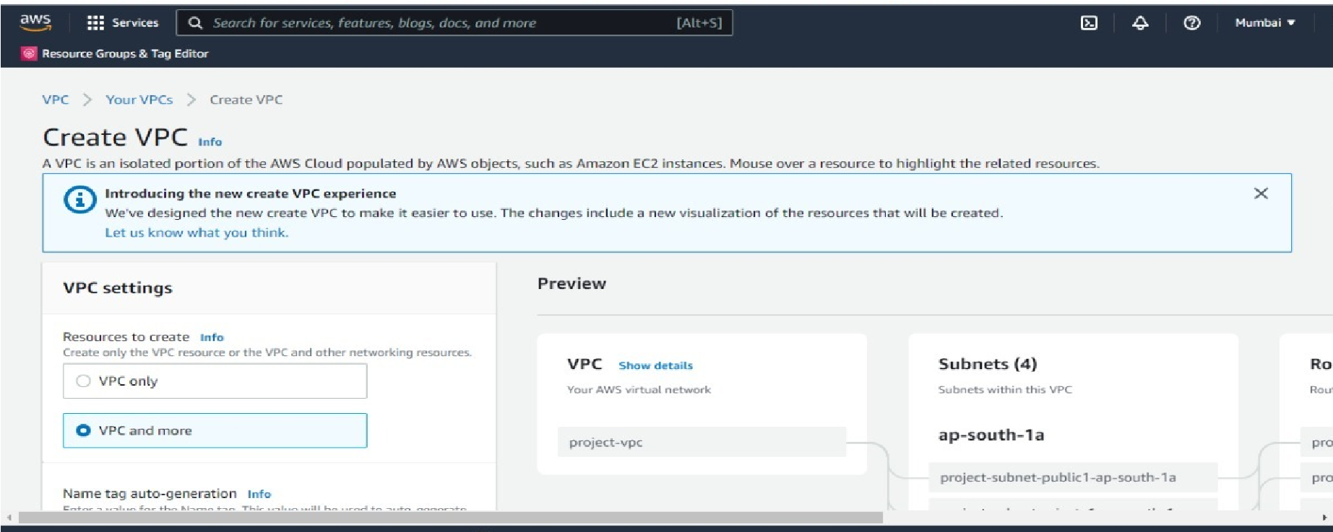

1. Select the number of Availability Zones (AZs) in which you wish to launch your subnets under Number of Availability Zones (AZs).
2. Select the quantity of public subnets you wish to add to your VPC under Number of public subnets.
3. Select the number of private subnets you wish to add to your VPC under Number of private subnets.
4. Now go to security group and create one security group.

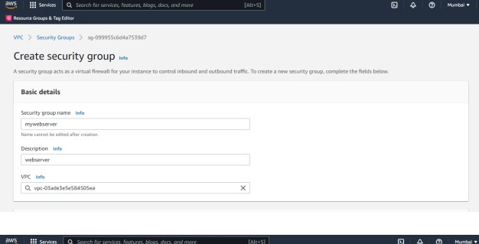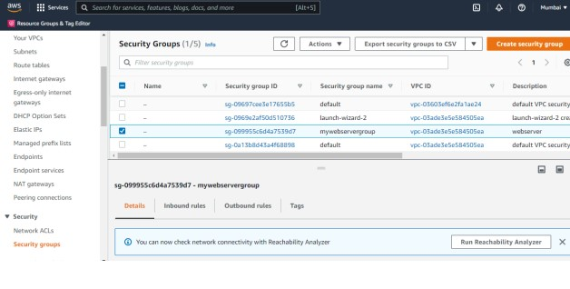

1. As your next step Make the following adjustments to the inbound rules.

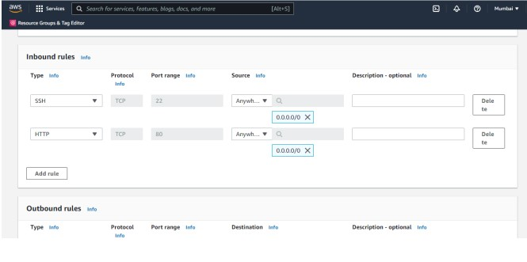

1. Now save the changes.

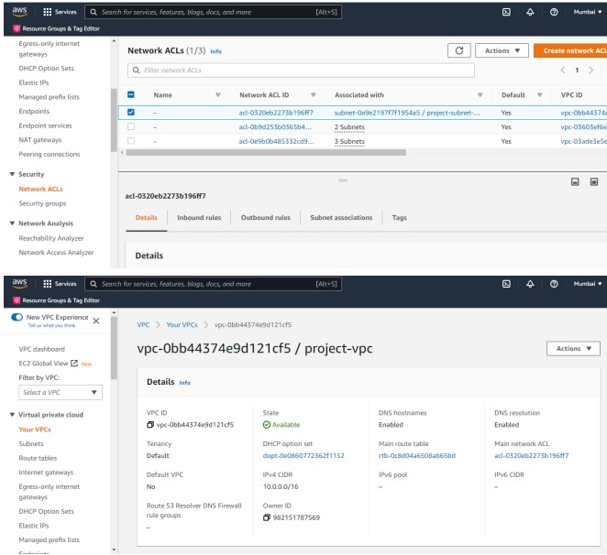

**RESULT:** The virtual private cloud has been successfully created and configured